Term Project: Chat Messenger
Design Document
Table of Contents
1 Introduction 2
1.1 Purpose and Scope 2
1.2 Target Audience 2
1.3 Terms and Definitions 2
2 Design Considerations 3
2.1 Constraints and Dependencies 3
2.2 Methodology 3
3 System Overview 4
4 System Architecture 5
4.1 Overall Architecture 5
4.1.1 User_list.txt 5
4.1.2 Mssg.txt 5
4.1+ Data Flow Diagram 6
5 Detailed System Design 7
5.1 Chat Messenger Premise 7
5.1.1 User List 7
5.1.2 Chat History 7
5.2 SVR UML Diagram 8
5.3 CLI UML Diagram 9

Introduction
This document is the Design Document for the CS300 Chat Messenger Client & Server applications.

Purpose and Scope
The purpose of this document is to provide high and low level explanations for the overall functionality of Chat Messenger, its major components, external data files, and a brief synopsis to the major implementation features required for it to run.

Target Audience
This document is intended both for executive readability, as well as developer reference. Refer to section 3 for the executive summary of the program. Refer to section 4 and 5 for the low level description of the system.

Terms and Definitions
CLI – Client application
SVR – Server applications
Customer – CS300 Term Project Customer (professor/TA).
End-user – Individual utilizing Chat Messenger services.

Design Considerations
The following section details constraints, dependencies, and the methodology used for the development of Chat Messenger.

Constraints and Dependencies
C1: The system will be implemented using Java.
C2: The system will use both Server (SVR) and Client (CLI) applications simultaneously.
C3: The system will need to work across a network.
C4: The system will incorporate GUI windows and elements.

Methodology
This program is intended to be designed using the Agile development methodology. The process includes a slowed-down form of Agile, allowing for 4x the normal amount of time for a single sprint. There will only be one sprint accomplished in this class, and is intended to go through the entire agile process of;

- Requirements (via Requirements Document)
- Planning (via Design Document)
- Design (via Design Document)
- Development (via Implementation and Testing
- Release (via Demonstration)
- Post-Release (ignored for the purposes of this class)

System Overview
Chat Messenger is a two-part application designed to allow users to connect and communicate over a centralized chat medium, specifically a chat window. The system includes both a Server (SVR) and Client (CLI) application that run simultaneously to provide capture information from users, and keep the user interface (chat window) updated while live.

End-users will register accounts upon their first use, which they are then expected to use to log into CLI and connect to SVR. Both the registration and login processes will require usernames and passwords.

Upon connecting to the service, they will be presented with a chat window. The chat window will display all messages from an external Mssg.txt data file. It will also display a list of users from an external User_list.txt data file. These users will be listed alphabetically, and will be stated whether offline or online.

Users will be able to read messages output to the text area of the chat window. They will also be able to send messages to the general chat room, or to specific users. All messages sent to/from the user will be recorded in a local chat_log.txt external data file, for their own records. All messages will be recorded to the SVR's chat log, Mssg.txt.

System Architecture
Chat Messenger utilizes two SVR external data files, one for user information and chat history respectively. These files are used to populate the user list and chat window with up-to-date information. Users then utilize the chat messenger application to send and read messages from one another.

Overall Architecture
A Flow Chart has been provided on the next page for visual aid. Chat Messenger utilizes both SVR and CLI applications simultaneously to facilitate the chatting experience. SVR is responsible for provided initial and refreshed chat messages, direct messages, user connection (and status messages), and the list of users to the Chat Window interface. CLI is responsible for facilitating registration and login of the end-user, processing messages into the local chat log, and allowing the user to send messages, and send direct messages, as well as opening the chat log directory and allowing the user to logout/quit the application.

User_list.txt
User_list.txt represents the formatted list of users registered to Chat Messenger. It includes their usernames, passwords, and connection status (Offline or Online). It is read into the SVR application on start up, where it will be packaged and provided to the chat window interface for display to all users. It is also regularly updated while SVR is running and accepting new users.

Mssg.txt
Mssg.txt represents the formatted list of Chat Messengers entire chat history. It includes the timestamps, usernames, to_user (in the case of direct messages), which are output to the chat window upon start. It is also updated when new messages are provided, so that it may update the chat window with new messages.

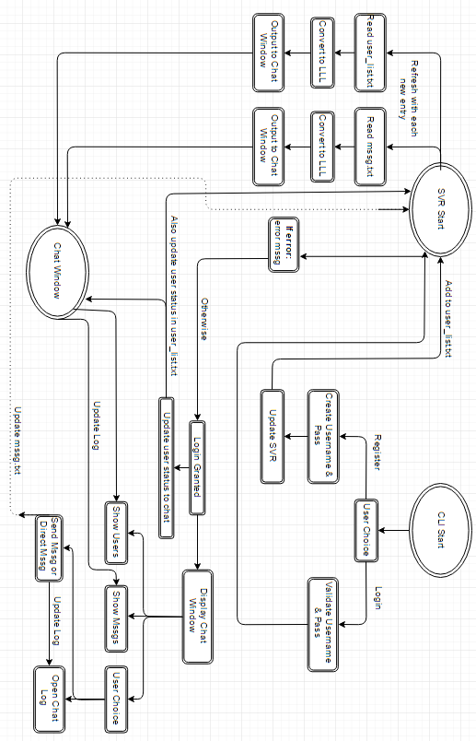

Detailed System Design

Chat Messenger Premise
As per the included UML diagrams – there are two major components of Chat Messenger, as well as the external data files stated below in 5.1.1 and 5.1.2. The SVR and CLI applications comprise the majority of the implementation for the system.

User List
User_list.txt will be read into two Linked Lists, where it will then be sorted alphabetically. The first list will be for online users, the second list will be for offline users. If a user comes online, they will be removed from the latter list and placed in the former, maintaining alphabetical readability.

Chat History
Mssg.txt will most likely be read directly to the screen output. It may later be changed to be stored in a data structure. When new messages are provided by end-users, Mssg.txt will be updated to reflect them.

SVR UML Diagram

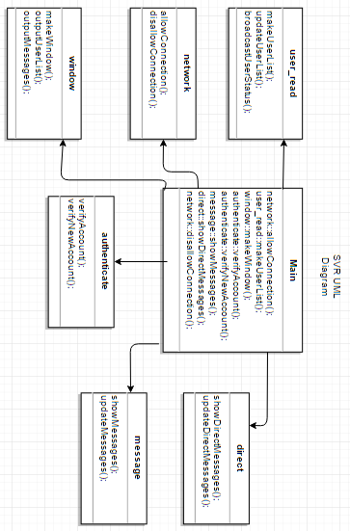

CLI UML Diagram

